Chapter 7, Solution 90.

We determine the Thevenin equivalent circuit for the capacitor 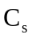.
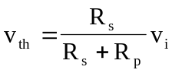, 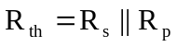

+
−
R_{th}
C_{s}
V_{th}

The Thevenin equivalent is an RC circuit. Since
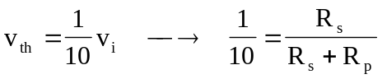
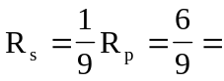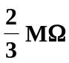
Also,
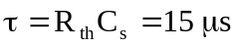
where 